Association for Mathematics in Education (AMiE)
The decision of five ‘classroom facing’ mathematics associations (Association of Mathematics Education Teachers (AMET), the Association of Teachers of Mathematics (ATM), the Mathematical Association (MA), the National Association of Mathematics Advisors (NAMA) and the National Association for Numeracy and Mathematics in Colleges (NANAMIC)) to further investigate the feasibility of continuing their work within a single charity was made at their AGMs last Easter. Mathematics is taught in a wide variety of settings. By working together in representing the different emphases of the five associations, the trustees hope to ensure that all sectors and special interests can be developed and sustained in the long term.

The initial trustees of the proposed AMiE would like to update you on the progress so far.

The initial members of the proposed charity are the five associations themselves. The appropriate committees of these associations appointed fourteen initial trustees in August 2022 to include seven trustees representing each of the associations (2 for ATM, 2 for MA and one for each of AMET, NAMA and NANAMIC) and seven independent trustees. The names of all the trustees and details about them can be found below.
There was a meeting of trustees in London where the application was agreed and has since been submitted to the Charity Commission through our solicitors, Bates Wells. The accompanying proposed constitution can be found here. Trustees have been working in four subcommittees since then to address key issues in relation to establishing the new Charitable Incorporated Organisation (CIO). This work will culminate in the production of a prospectus for the CIO, outlining a proposed framework for the new organisation and this will be available to all members of the existing five associations by the end of March.

Subcommittees
Membership & Budgeting: Fiona Allan, David Miles, Richard Spillett, Paul Treversh.
Office & Staffing: Jenni Back, Helen Madeley, Sue Madgwick, David Miles.
Reviewing Previous Documents: Jenni Back, Claire Baldwin, John Barton, Helen Madeley.
Bank, Logo & Social Media: Fiona Allan, Claire Baldwin, John Barton, Richard Spillett.
Initial Trustees of AMiE
Fiona Allan studied Education, specialising in Maths, at Edinburgh University and qualified to teach in both primary and secondary schools. She taught all ages from five to 18, before spending 17 years in a Sixth Form College, where she taught all levels of Maths from Entry to A-level and set up and led Numeracy and Access to A-level courses. Fiona left the classroom to complete an MSc in Computer Enhanced Maths Education and to work in the Standards Unit’s ‘Improving learning in mathematics’ team. Since then she has worked on many national and university projects, including the Maths Enhancement Programme which upskilled over 2,000 Further Education teachers to enable them to teach students resitting GCSE Maths. Fiona also worked part time for the National Centre for Excellence in the Teaching of Mathematics for 13 years. She was the FE representative for six years on the Royal Society’s ACME. Fiona is an independent trustee.
Jenni Back is a freelance researcher and developer with experience of teaching mathematics to students of all ages. She was co-ordinator of resources for primary teachers and children at NRICH, University of Cambridge and has been involve in teacher education with Middlesex University, the Centre for Innovation in Mathematics Teaching at Plymouth University and NCETM. She is passionate about mathematics and its teaching and learning especially in relation to young children and is one of the authors of 'Making Numbers' and 'Making Fractions’, published by Oxford University Press and developed as part of two Nuffield Foundation funded projects. Jenni is an independent trustee.

Claire Baldwin started her career as an 11-18 maths teacher after graduating with a first-class degree in Mathematics, Statistics & Operational Research from UMIST. She has worked in a wide range of settings including comprehensive schools, grammar schools and sixth form colleges, during which she completed her MA Mathematics Education. She spent 4 years working as a PGCE Secondary Course Leader in a University before taking on roles as a Maths & Science Department Leader and later Assistant Principal (Curriculum & Standards) in a sixth form college in the Northwest of England. She has also worked extensively as a GCSE Statistics and Mathematics examiner and Team Leader for one of the main English Awarding Organisations.
Claire is now Director for Student Engagement at MEI, a senior leadership role, and is passionate about improving opportunities within maths education for all students, regardless of their background or individual characteristics. Claire is an independent trustee.

John Barton trained as a primary teacher specialising in mathematics. After working in a junior school for many years he moved into adult education, working for a Further Education college. He became a manager in the post-16 sector specialising in numeracy, literacy and learning support. As a teacher trainer he trained hundreds of maths teachers from across the post-16 sector to achieve the appropriate level 5 qualification and hundreds more to effectively deliver GCSE re-sit maths.
Since 2011 he has been the chair of the National Association for Numeracy and Mathematics in Colleges and from 2014 until 2023 he was the inaugural chair of the South Yorkshire Maths Hub.
John is the NANAMIC representative trustee and acting chair of the CIO.
Karen Gladwin has been involved in teacher education for the last 20 years. Before that she taught mathematics across all years from Y5 to A Level in a range of middle, secondary and high schools. As part of the Suffolk Maths team she worked across the county delivering the National Strategy. She is always looking for ways to promote mathematics with struggling learners. Her current research interests include Neurodiversity in Academia: Strength or Shame. She has experience of leading conferences including the British Congress of Mathematics Education (BCME) in 2006 and 2018.

Karen is the AMET representative trustee.

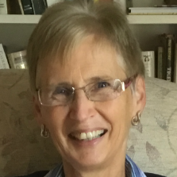
Jennie Golding is an Oxford mathematician by background. She has had a variety of 5-18 school-based leadership roles teaching mathematics, leading teacher development in England and in poorly resourced contexts elsewhere, and working in (inter)national education policy, including ongoing roles as a subject expert for the Department for Education and Ofqual. Now at University College London, her research is largely ‘classroom-close’, focused on ways systemic developments can support teachers and learners to realise their potential. She is currently completing qualitative studies of ‘The New (post-pandemic) Normal’ across school phases, and leading England research for Trends in International Mathematics and Science Study (TIMSS).
Jennie has been vice-chair of ACME and a trustee of the Joint Mathematical Council of the UK. She passionately believes that all young people can enjoy confident and effective use of mathematics when they have appropriate learning opportunities. Jennie is an independent trustee.

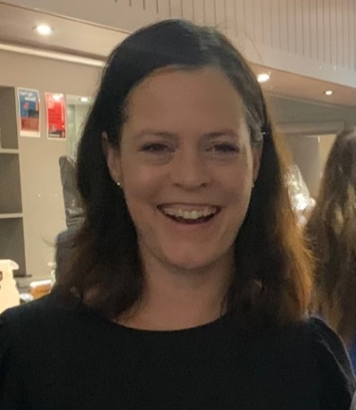
Jen Hill-Parker has worked in state secondary schools for twenty-five years, and is currently Director Of Maths for the Acorn Trust in Wiltshire. She has worked as an examiner for Pearson for Key Stage Four and Five exams and gained status as a Specialist Leader in Education (SLE) and then as a Local Leader in Education (LLE). Jen wrote a set of Guided Reading resources and a set of Diversity, Equality and Inclusion resources, both of which were published by Pearson and sent to all schools. Jen has a keen interest in etymology and is currently working on using Tiered vocabulary within the mathematics classroom. Jen is an independent trustee.
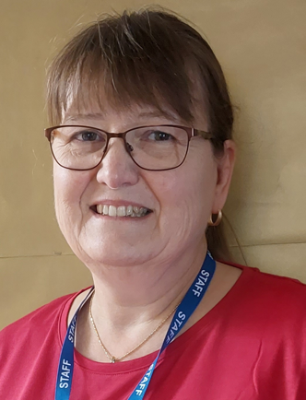
Ruth James is a Primary Headteacher in a rural village school. As one of the first cohort to undertake the Primary Mathematics Specialist Teacher Programme (MaST), it has led to a Masters Degree in Primary Mathematics Education and a passion for teaching mathematics to young children. She has written articles for both ATM and MA magazines and has contributed to books and other publications, often based on action research in the classroom from a variety of different sized schools where she was teaching. Ruth has spent time as a Mathematics Advisor for a local authority, as well as giving outreach support to other schools. Ruth is a teaching Headteacher and is keen to spend time with children understanding how they approach mathematics learning in different ways. Ruth is an independent trustee.
Ems Lord is the current Chair of The Mathematical Association. Ems is based at the University of Cambridge where she is the Director of NRICH mathematics outreach project. She is a Research Fellow in the Sciences, a fellow of The Institute of Mathematics and its Applications, and a Founding Fellow of the Chartered College of Teachers. Ems has taught mathematics from Early Years to A Level Further Mathematics and previously led a regional Masters-level Mathematics Specialist Teacher (MaST) programme and has taught mathematics education on both BEd and PGCE teacher programmes.
Ems is one of the representative trustees for the MA.
Helen Madeley trained as a secondary teacher of mathematics teaching in two secondary schools, including as Head of Department, and two primary schools, including being maths subject lead. She was a lecturer at an HEI until earlier this year with responsibility for the maths curriculum and provision and is currently a Maths Hub Lead. In addition to hub leadership, she leads on a number of projects for the NCETM, is a school governor and Vice Chair, and a trustee for the Association of Teachers of Mathematics (ATM) where she is Chair of the General Council.
Helen is one of the ATM representative trustees.

Sue Madgwick is currently the Deputy National Director for the NCETM and has held this role for four years. Prior to that Sue had a variety of roles in education including a previous role in the NCETM, working as a secondary mathematics teacher and a local authority maths adviser whilst also working for a School-Centred Initial Teacher Trainer in the Southwest. Sue is an independent trustee.

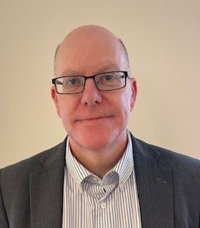
David Miles has been a Senior Leader of one of the largest state secondary schools in Suffolk for ten years. He has taught GCSE mathematics, A level mathematics and A level further mathematics for over twenty years and has acted as an A level examiner. He has edited and authored books and teaching resources for The Mathematical Association (MA) and has contributed to the production of national and international assessments.
David has served on the MA Council for the last ten years and has held various positions including Treasurer and Chair of the Teaching Committee.
David is one of the MA representative trustees.

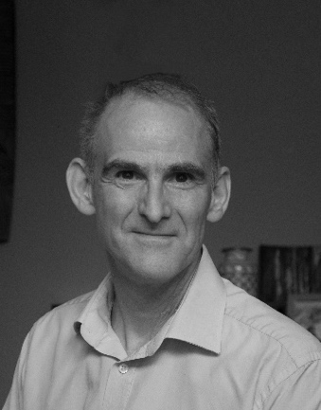
Richard Spillett has a deep passion for mathematics which he developed at school and shaped his career in investment banking. As a trader of structured derivatives, he was part of what has grown into a trillion-dollar industry at whose core has been solving stochastic differential equations. He recently retired from Credit Suisse where he was the Global Head of Emerging Markets. His enjoyment of all things mathematical is the result of inspirational teachers and understand how influential they can be. He is excited to work with a team supporting these teachers who are inspiring the next generation and are making the beauty of mathematics accessible.
His insight into the demands industry makes of new mathematicians together with his experience in the commercial sector will be invaluable.
Richard is one of the ATM representative trustees.
Paul Treversh started his career teaching in a range of secondary schools working at both subject and senior leadership before working for a local authority and then as an independent consultant. He has worked as an examiner for a number of awarding bodies. Paul has spent the last five years working for NCETM where he is currently Assistant Director for System Leadership. This role involves supporting maths system leaders, especially within Maths Hubs, and working with national and regional partners. He has served on the NAMA Executive Committee for more than eight years.

Paul is the NAMA representative trustee.

